Room haveing Smoke sensor with buzzer alarm and two light bulb and

Two fans .

Code:

const int gasPin = A0;

void setup()

{

Serial.begin(9600);

}

void loop()

{

Serial.println(analogRead(gasPin));

delay(1000);

}

Output:

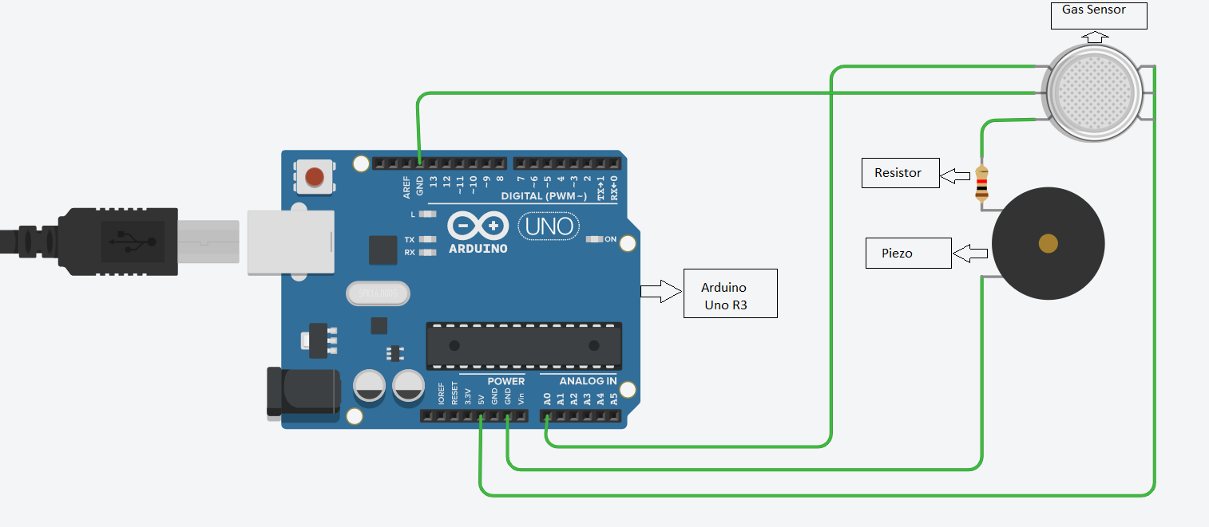

1. void setup()

{

pinMode(13, OUTPUT);

}

void loop()

{

digitalWrite(13, HIGH);

delay(1000); // Wait for 1000 millisecond(s)

}

Output:

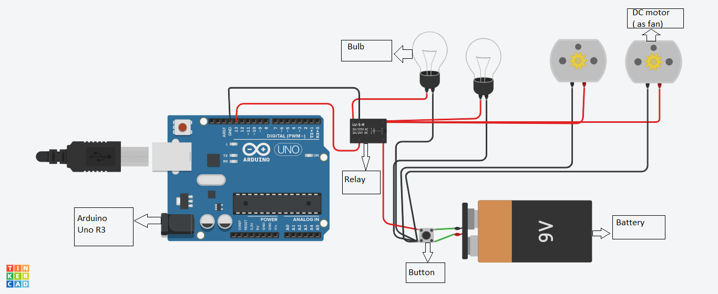

1. PIR sensor to detect motion and light the bulb.

Code:

int releNO = 13;

int inputPir = 2;

int val = 0;

int resuldoSensorLDR;

int sensorLDR = A0;

void setup()

{

pinMode(releNO, OUTPUT);

pinMode(inputPir, INPUT);

pinMode(sensorLDR, INPUT);

Serial.begin(9600);

}

void loop()

{

val = digitalRead(inputPir);

resuldoSensorLDR = analogRead(sensorLDR);

if(resuldoSensorLDR<600)

{

if(val == HIGH)

{

digitalWrite(releNO, HIGH);

delay(5000);

}

else{

digitalWrite(releNO, LOW);

delay(300);

}

}

else{ digitalWrite (releNO, LOW);

Serial.println(resuldoSensorLDR);

delay(500);

}

}

Circuit diagram:

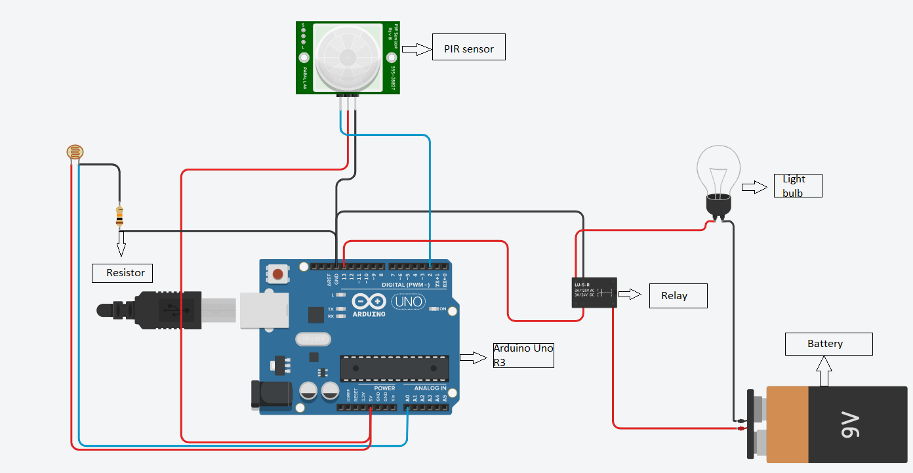

1. Water Level Detector.

Code:

void setup()

{

pinMode(13, OUTPUT);

}

void loop()

{

digitalWrite(13, HIGH);

delay(1000); // Wait for 1000 millisecond(s)

digitalWrite(13, LOW);

delay(1000); // Wait for 1000 millisecond(s)

}

Output:

